Object Oriented Programming

Philip Woulfe  | Dublin

Report, Design and Testing document

Woulfe, Philip

2016

Contents

Task One - Principles, Characteristics and Features of Object Oriented Programming 2

Introduction 3

Principles, Features & Characteristics 4

Shared with Non Object Oriented Programming Languages 4

Classes and Objects 4

Inheritance 4

Encapsulation 5

Abstraction 5

Polymorphism 5

Conclusion 7

Task Two - Airline Booking System Design Document 8

User Stories 9

0001 – Customer Password Validation (Not part of customer specification) 9

0002 – Administrator Password Validation 9

0003 – Booking flights 9

0004 – Confirmation Screen 10

0005 – Maintenance Suite 10

GUI Layouts 11

UML 17

Databases 18

Task Three – Source Code 19

Task Four – Testing Report 20

Bibliography 21

# Task One - Principles, Characteristics and Features of Object Oriented Programming

## Introduction

Object-oriented programming (OOP) is a programming paradigm which is based on the concept of objects which contain attributes and methods. The attributes store data about the object and the methods are ways of manipulating that data. Many OOP languages use classes as the basis for the objects. Classes can be thought of as blueprints for the object that is created from them. OOP works by making these objects interact with each other.

One of the earliest languages to use the concept of objects was SIMULA 67 in 1961. (Holmevik, 1994) By the early 90s, OOP had become the dominant paradigm with languages like C++ and Visual FoxPro becoming available. Many non OOP languages like FORTRAN and COBOL had OOP features added to them. Two of the most important commercial OOP languages are Java and C#.

## Principles, Features & Characteristics

### Shared with Non Object Oriented Programming Languages

Some features of OOP that are shared with non OOP languages are variables and procedures.

#### Variables

Variables are used to store information. These can be primitive variables such as:

* natural numbers
* characters
* floating point numbers
* booleans

Or object variables such as:

* strings
* lists
* even object versions primitive variables

Primitive variable work by holding the information directly, whereas object variables work by holding a reference to the object location.

#### Procedures

Procedures are a way of manipulating data. This can be methods taking input and providing output or it can be structures like if statements or loops.

### Classes and Objects

#### Classes

Classes are the blueprint for an object, you may create a *Dog* class and give it a *numberOfLegs* variable and a *bark()* method. The *numberOfLegs* variable will hold a number denoting how many legs the dog has and whenever the *bark()* method is called, the dog will bark. However the dog cannot bark until it is created.

#### Objects

Objects are instances of a class. You may take the *Dog* class and instantiate it. In this Java example, the first *Dog* refers to the variable type, which is the object the variable is going to hold, *dougal* refers to the name of the variable (i.e. the dog’s name), new tells Java to create a new object and *Dog()* is the constructor method. This is located in the *Dog* class and tells Java how to create a *Dog* object.

**Dog** dougal = **new** Dog();

You can now check the number of legs the dog has by checking *dougal.numberOfLegs* and you can make him bark by calling *dougal.bark().*

### Inheritance

Inheritance is a way of reusing code in multiple classes. For example, the previously mentioned *Dog* class shares some attributes with a *Human* class. They both have legs, they both have eyes, and they both feed their young milk; although some of these values may be different. Instead of writing out the same code twice, we can write a superclass called *Mammal* and include all the common features of both in it. When the *Dog* object is created, *numberOfLegs* is set to *4* and when the human object is created *numberOfLegs* is set to *2*. The different methods like *bark()* and *speak()* can be written into the *Dog* and *Human* classes respectively, or we could have a *speak()* method in the *Mammal* class and implement it differently for *Dog* and *Human*.

### Encapsulation

Encapsulation is a way of hiding information to prevent it from being accessed outside a class. Java does this by using keywords such as *public*, *protected*, *private* and, although it is not a keyword, just an absence of one, *default*. *Public* information can be accessed from any object, *protected* can be accessed by the class, the package and subclasses, *default* can be accessed by the class and package and *private* can only be accessed by the class.

#### Accessor

Accessor methods can also be called getter methods. Accessor methods are used to allow information to be retrieved from variables you can’t access directly. This means you can read the contents of the variable, but not change it. To change the value, you must use a mutator method.

#### Mutator

Mutator methods allow private variables to be changed, but also allow validation of the data you are trying to store in the variable. Mutator methods can also be called setter methods.

In this Java example, this *setAge()* setter method won’t allow age to be set to a negative number from outside the class. Instead it prints an error message to the console. If the object age variable was public, it could be set to any number from negative 2 billion to positive 2 billion. Using setter methods like this prevents other programmers from implementing your classes in a way you didn’t intend.

**private** **int** age;

**public** **void** setAge(**int** age) {

**if** (age >= 0) {

**this**.age = age;

} **else** {

System.out.println("Age must be a positive integer");

}

}

### Abstraction

Abstract classes are classes that cannot be instantiated into objects. An example of this would be the Mammal class previously mentioned. There is no animal known only as a mammal, all mammals are another type of animal.

Abstract methods are methods which are defined by the input and output type but are not implemented.

The mammal class would have abstract methods such as *createYoung()*. The reason for this abstract method is the fact that all mammals produce offspring, however, not all mammals give birth to live young; monotremes such as the platypus and the echidna lay eggs instead; so while both create offspring, the logic for doing so would be different.

### Polymorphism

Polymorphism comes from the Greek, *polys* meaning “many” and *morphē* meaning “form”. Polymorphism is when calling code can accept a parent class or any of its sub classes.

In this Java example, *Platypus* implements *EggLayer* and extends *Mamma*l, therefore

* A Platypus IS-A EggLayer
* A Platypus IS-A Mammal
* A Platypus IS-A Object (All classes in Java extend object)

**public** **interface** EggLayer{}

**public** **abstract** **class** Mammal{}

**public** **class** Platypus **extends** Mammal **implements** EggLayer{}

This means these classes can be created and assigned as follows.

Platypus p = **new** Platypus();

Mammal m = p;

EggLayer e = p;

Object o = p;

All the reference variables p, m, e, o refer to the same *Platypus* object.

## Conclusion

# Task Two - Airline Booking System Design Document

## User Stories

### 0001 – Customer Password Validation (Sprint 2)

As a customer, I would like to be able to login to the application so I can book a flight.

Customers should be provided with a username and password which allows them to login to the application. Entering an incorrect username or password should display an error message.

|  |  |
| --- | --- |
| Criteria 1 | Entering correct username and password allows access to the application |
| Criteria 2 | Cancel button exits application |

#### Happy Case:

#### Error Validation:

|  |  |
| --- | --- |
| Criteria 1 | If an incorrect username or password is entered, display message: “Username or password incorrect” |
| Criteria 2 | If an incorrect username or password is entered, the password field will clear on clicking the Ok button |
| Criteria 3 | If username field is left blank, display error “Username is a required field |
| Criteria 4 | If password field is left blank, display error message “Password is a required field” |
| Criteria 5 | If the database cannot be reached, display error “Database cannot be reached” |

### 0002 – Administrator Password Validation

As an administrator, I would like to be able to login to the application so I can add or remove airports from the application and view details of booked flights.

Administrators should be provided with a username and password which allows them to login to the application. This should allow them access to the maintenance suite. Entering an incorrect username or password should display an error message.

#### Happy Case:

|  |  |
| --- | --- |
| Criteria 1 | Entering correct username and password allows access to the maintenance suite. |

#### Error Validation:

|  |  |
| --- | --- |
| Criteria 1 | If an incorrect username or password is entered, display message: “Username or password incorrect” |
| Criteria 2 | If an incorrect username or password is entered, the password field will clear on clicking the Ok button |
| Criteria 3 | If username field is left blank, display error “Username is a required field |
| Criteria 4 | If password field is left blank, display error message “Password is a required field” |
| Criteria 5 | If the database cannot be reached, display error “Database cannot be reached” |

### 0003 – Booking flights

As a user, I would like to be able to select criteria in the application so I can book flights.

Customers should be able to select three criteria, namely departure airport, destination airport and type of seat for each leg of the journey. The customer should be able to select a second leg, on from the first destination or back to the original airport. The passenger name should be recorded and a booking reference assigned. On completion, details of the flight(s) should be displayed on screen for the customer to confirm. On confirmation, details should be written to a file.

#### Happy Case:

|  |  |
| --- | --- |
| Criteria 1 | GUI should use combo boxes, radio buttons and at least one checkbox. |
| Criteria 2 | Application should have around eight airports. |
| Criteria 3 | Departure airport, destination airport and type of seat should be selectable for each leg of the journey. |
| Criteria 4 | Departure and destination airports should be displayed in alphabetical order. |
| Criteria 5 | It should be possible to book a second leg, onward from the first destination or back to the original departure airport. |
| Criteria 6 | There should be three choices of seat: Economy, Business & First Class |

#### Error Validation:

|  |  |
| --- | --- |
| Criteria 1 | Departure and destination airport cannot be the same. |
| Criteria 2 | If any combo box is blank, do not allow booking flights and display error message |

### 0004 – Confirmation Screen

As a user, I would like my booking details to be displayed on screen so I can review the details before I confirm them.

Users should have the booking details displayed on screen so they can ensure all the information is correct before confirming the flight.

#### Happy Case

|  |  |
| --- | --- |
| Criteria 1 | Passenger name should be recorded and a Booking Reference assigned. |
| Criteria 2 | When completed, details of the flight(s) booked should be displayed on the screen for the user to confirm. |
| Criteria 3 | On confirmation, details should be written to a file. |

#### Error Validation:

|  |  |
| --- | --- |
| Criteria 1 | If the information cannot be written to the database, display error message |

### 0005 – Maintenance Suite

As an administrator, I would like to be able to Access a maintenance suite so I can modify the application.

Administrators should be able to access the maintenance suite in order to add or remove airports to the application and also to view the booked flights. Each airport will have a unique three character code; this will prevent the same airport being added twice.

#### Happy Case:

|  |  |
| --- | --- |
| Criteria 1 | Administrators should be able to add or remove airports from the application. |
| Criteria 2 | When an airport is removed, it should no longer appear in the application. |
| Criteria 3 | When an airport is added, it should appear in the application. |
| Criteria 4 | Administrators should be able to view booked flights from the maintenance suite. |
| Criteria 5 | Administrator should be able to add new users (Sprint 2) |

#### Error Validation:

|  |  |
| --- | --- |
| Criteria 1 | Administrators should not be able to add the same airport twice. (Sprint 2) |

## GUI Layouts

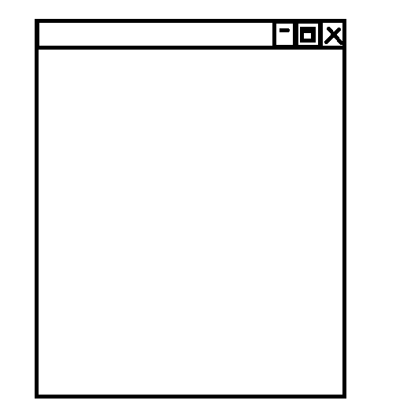

Figure - Main GUI

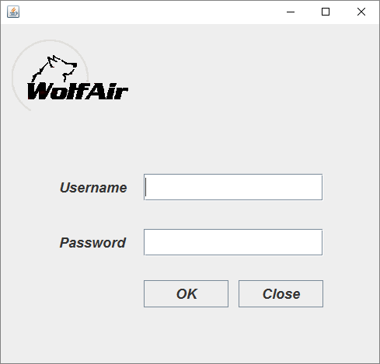

Figure - Login GUI

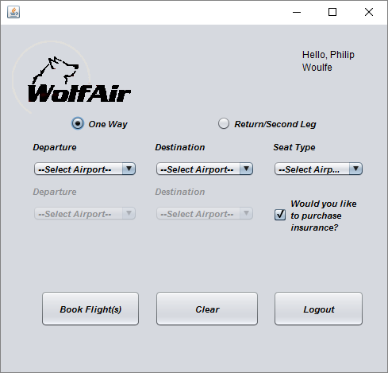

Figure - Customer GUI

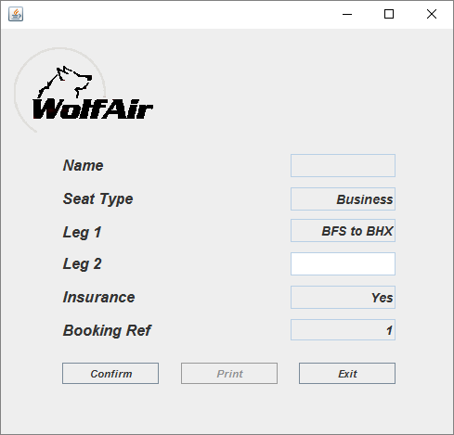

Figure - Customer Confirmation Screen

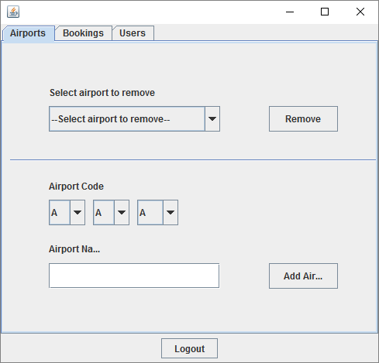

Figure - Airport Maintenance Screen

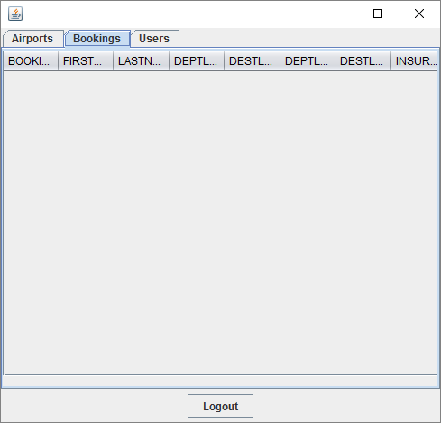

Figure - Flight Maintenance Screen

## UML

## Databases

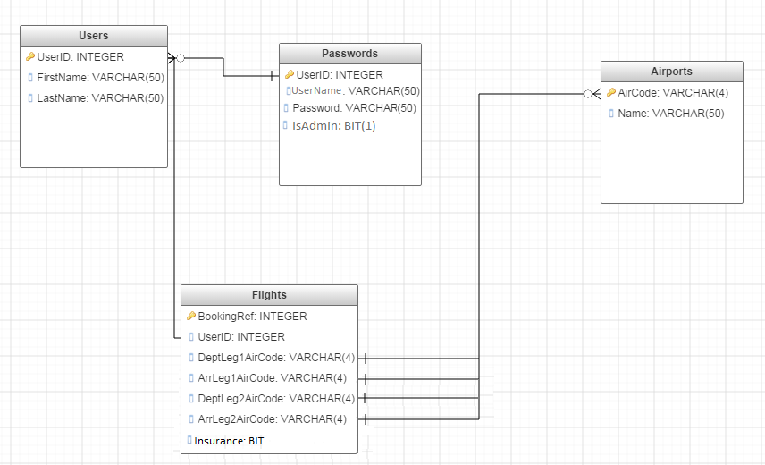

Figure - Database Diagram

# Task Three – Source Code

# Task Four

## Testing of the application

## Analysis of actual test results against expected results to identify discrepancies

## Recommendations for improvements to the program

## Documentation for use of the program by other programmers

## A program with onscreen help to guide users of your program

# Bibliography

Holmevik, J. R. (1994). *Compiling SIMULA: A Historical Study of Technological Genesis*. Retrieved 03 01, 2016, from www.ntnu.no: http://www.idi.ntnu.no/grupper/su/publ/simula/holmevik-simula-ieeeannals94.pdf

Lewallen, R. (2005, 07 19). *4 Major Principles of Object Oriented Programming*. Retrieved from codebetter.com: http://codebetter.com/raymondlewallen/2005/07/19/4-major-principles-of-object-oriented-programming/